**// Create a Stack ADT using Array Data structure and perform its //operations**

#include <iostream.h>

#include<conio.h>

int stack[100], n=100, top=-1;

void push(int val){ //function to push an element on stack top

if(top>=n-1)

cout<<"Stack Overflow"<<endl;

else {

top++;

stack[top]=val;

}

}

void pop() { //function to remove an element from the stack top

if(top<=-1)

cout<<"Stack is empty"<<endl;

else {

cout<<"The popped element is "<< stack[top] <<endl;

top--;

}

}

void peek() { //function to view all the elements in the stack

if(top>=0) {

cout<<"Elements in stack are:"<<endl;

for(int i=top; i>=0; i--)

cout<<stack[i]<<" "<<endl;//printing all the values inside the stack

}

else

cout<<"Stack is empty"<<endl;

}

void main() {

clrscr();

int option, val;

cout<<"\n STACK ADT OPERATIONS USING ARRAY\n";

cout<<"1) Push an element into stack"<<endl;

cout<<"2) Pop the last element stack"<<endl;

cout<<"3) Display the stack"<<endl;

cout<<"4) Exit"<<endl;

while(option!=4) {

cout<<"Enter choice: "<<endl;

cin>>option;

switch(option) {

case 1: {

cout<<"Enter value to be pushed:"<<endl;

cin>>val;

push(val);

break;

}

case 2: {

pop();

break;

}

case 3: {

peek();

break;

}

case 4: {

cout<<"Exiting.."<<endl;

break;

}

default: {

cout<<"Invalid Choice"<<endl;

}

}//switch case ends here

}//while loop ends here

}//void main ends here

**OUTPUT:**

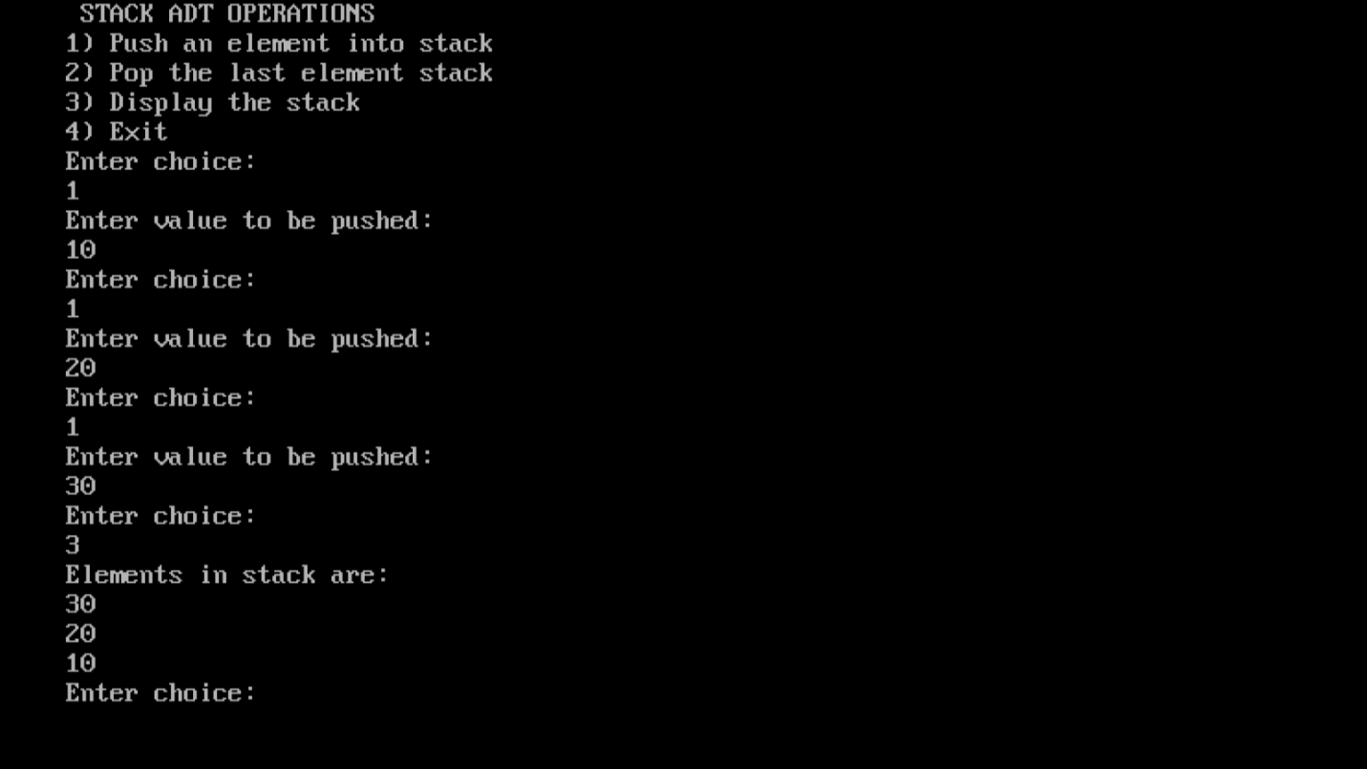

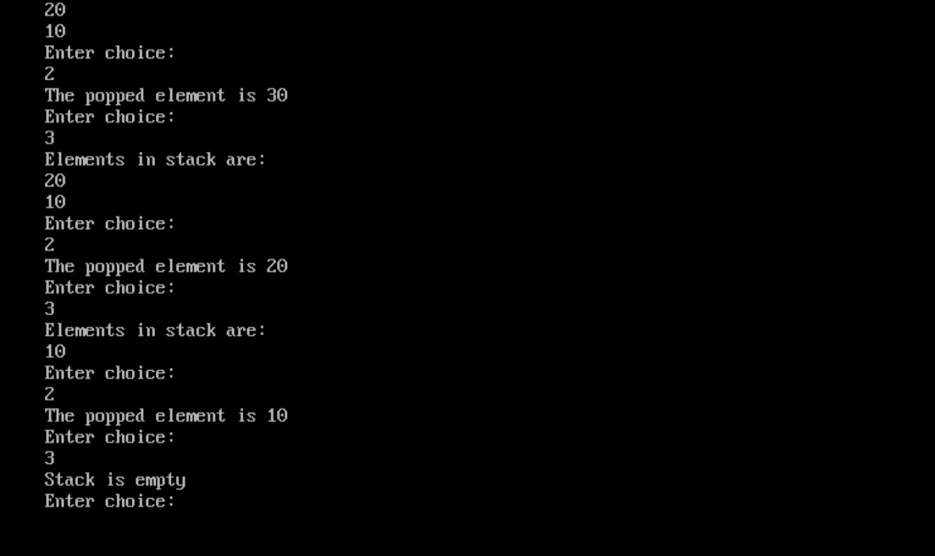

**//This code was contributed by Vijeyandrian MCA Section ’B’**